(The video performance in the link I provided is not the same length as my teacher provided me on my school website, and it won’t allow me to download it, so i can only find this concert on youtube. sorry for the trouble. The actual video begins at 0:23, which is at 0:00 of the video my teacher provided. there are some questions that ask such as “where does the cadenza occur”, please minus 23 seconds after finding the time period and then choose the correct answer. Thank you!)

QUESTION 1
- The _________ movement has its roots in the values of order and reason expressed by the ancient Greeks and Romans, who laid the foundations for the very notion of European identity.
 | 1. | Classical
 | 2. | Romantic
 | 3. | Baroque
 | 4. | Modernist
10 points

QUESTION 2
- The late 1700s and early 1800s were a time when writers, artists, architects, and composers alike were fascinated with classical ideals as well as a philosophical and intellectual movement that emphasized the centrality of reason in the human experience. What this philosophical and intellectual movement called?
 | 1. | The Reformation
 | 2. | The Counter-Reformation
 | 3. | The Enlightenment
 | 4. | The Counter-Enlightenment
10 points

QUESTION 3
- How did Classical and Enlightenment ideals shape the music of the late 1700s and early 1800s? Please select all answers that apply.
 | 1. | Whether fast or slow, tempos tend to be steady.
 | 2. | Much of the music of this era tends to be in one of the four basic meters—2/4, 3/4, 4/4, or 6/8—with few internal metrical shifts.
 | 3. | Melodies are typically constructed from symmetrical, balanced, four-bar phrases with clear-cut cadences.
 | 4. | Harmonies tend to be diatonic—in other words, built from the seven tones of the scale—and thus are strongly rooted in the key area.
10 points

QUESTION 4
- Over the course of the Classical era, the patronage system—in which wealthy patrons supported composers, whether by employing them, commissioning new works by then, or simply providing them with stipend—gradually declined. One Classical composer enjoyed an especially long—and, it would seem, highly productive—relationship with his patron, Prince Esterhàzy, and his patron’s family. Who was this composer?
 | 1. | Ludwig van Beethoven
 | 2. | Wolfgang Amadeus Mozart
 | 3. | Joseph Haydn
10 points

QUESTION 5
- Unlike his immediate predecessors, one Classical composer never allowed the aristocracy to treat him like a servant, and he never produced music at a patron’s demand; throughout his career, he demanded the right to produce whatever music he desired—and still to be supported financially. Who was this composer?
 | 1. | Joseph Haydn
 | 2. | Wolfgang Amadeus Mozart
 | 3. | Ludwig van Beethoven
10 points

QUESTION 6
- The composer of the work you are studying for Exam #3 was initially employed by a wealthy patron, but later struck out on his own as a freelancer, making a modest living from teaching private piano students, performing on the piano at public concerts, and composing musical works he was commissioned to write. In fact, he was in the middle of composing one such commissioned work—a Requiem Mass, which the count who commissioned it planned to pass off as his own—when he died. Who was this composer?
 | 1. | Ludwig van Beethoven
 | 2. | Wolfgang Amadeus Mozart
 | 3. | Joseph Haydn
10 points

QUESTION 7
- During the Classical era, the concerto tended to feature _________ supported by an orchestra.
 | 1. | one soloist
 | 2. | two soloists
 | 3. | three soloists
 | 4. | four or five soloists
10 points

QUESTION 8
- This late eighteenth-century engraving by Johann Rudolf Holzhalb depicts the performance of a solo piano (or “cembalo”) concerto. Using your cursor, please click on the soloist.
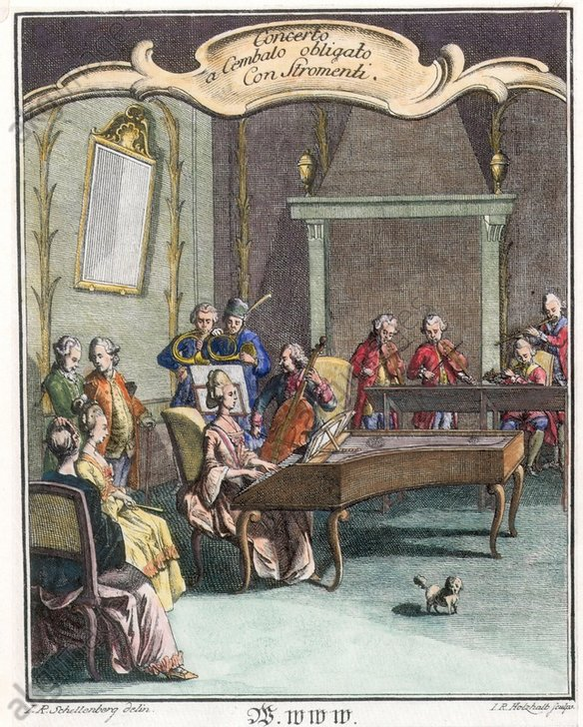
Selected CoordinatesClear
10 points

QUESTION 9
- One unique feature of the solo concerto is the _________ , a virtuosic solo passage in the manner of an improvisation that comes toward the end of a movement.
 | 1. | cadenza
 | 2. | cantabile
 | 3. | coda
 | 4. | crescendo
10 points

QUESTION 10
- The composer of the musical work you are a studying for this exam premiered many of his piano concertos himself, so he rarely wrote out his cadenzas in full. Instead, he typically wrote just two chords into the piano part—the first and the last of the cadenza—in between which he would improvise the cadenza itself. In the musical score provided below, the piano part has been identified with a red box. Using your cursor, please click on the space in between the pianist’s two chords—in other words, in the space in which the pianist would have improvised the cadenza. [Hint: the word "cadenza" is printed in the score at this point, just in case the pianist—or anyone else—is confused about where this should take place!]
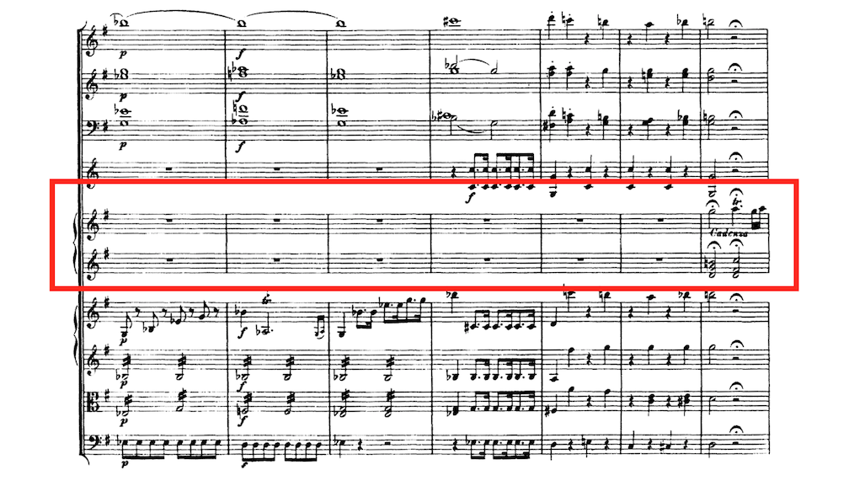
Selected CoordinatesClear
10 points

QUESTION 11
- To signal that the orchestra should pause indefinitely while the pianist performs the cadenza, the composer would typically write the symbol pictured here over each of the orchestral parts.

What is this symbol called?
 | 1. | furioso
 | 2. | fermata
 | 3. | forte
 | 4. | fuoco
10 points

QUESTION 12
- In the video performance, where does the cadenza occur?
 | 1. | 0:30-2:45
 | 2. | 2:45-6:05
 | 3. | 6:05-7:25
 | 4. | 7:25-10:30
 | 5. | 10:30-12:20
 | 6. | 12:20-end
10 points

QUESTION 13
- First-movement concerto form is sometimes described as a sonata-allegro form with a double _________ , both of which present the two themes (separated by a bridge or transitional passage).
 | 1. | development
 | 2. | recapitulation
 | 3. | coda
 | 4. | exposition
10 points

QUESTION 14
- In the video performance, where does the first (orchestral) exposition occur?
 | 1. | 0:30-2:45
 | 2. | 2:45-6:05
 | 3. | 6:05-7:25
 | 4. | 7:25-10:30
 | 5. | 10:30-12:20
 | 6. | 12:20-end
10 points

QUESTION 15
- In the video, where does the second (soloist + orchestral) exposition occur?
 | 1. | 0:30-2:45
 | 2. | 2:45-6:05
 | 3. | 6:05-7:25
 | 4. | 7:25-10:30
 | 5. | 10:30-12:20
 | 6. | 12:20-end
10 points

QUESTION 16
- Conventional first-movement concerto forms and sonata-allegro forms typically feature a middle section characterized by conflict, tension, and drama, all of which is heightened by the music’s wandering through a series of foreign key areas. What is this section called?
 | 1. | recapitulation
 | 2. | coda
 | 3. | development
 | 4. | exposition
10 points

QUESTION 17
- In the video performance, where does the development occur?
 | 1. | 0:30-2:45
 | 2. | 2:45-6:05
 | 3. | 6:05-7:25
 | 4. | 7:25-10:30
 | 5. | 10:30-12:20
 | 6. | 12:20-end
5 points (Extra Credit)

QUESTION 18
- In conventional first-movement concerto forms and sonata-allegro forms, the section that immediately follows the development is the psychological climax of the movement, satisfying the listener’s need for unity, symmetry, and resolution. What is this section called?
 | 1. | coda
 | 2. | exposition
 | 3. | recapitulation
 | 4. | development
10 points

QUESTION 19
- In the video performance, where does the recapitulation occur?
 | 1. | 0:30-2:45
 | 2. | 2:45-6:05
 | 3. | 6:05-7:25
 | 4. | 7:25-10:30
 | 5. | 10:30-12:20
 | 6. | 12:20-end
5 points (Extra Credit)

QUESTION 20
- Movements in first-movement concerto form often end with a short orchestral section called a _________ .
 | 1. | crescendo
 | 2. | cantabile
 | 3. | coda
 | 4. | cadenza
10 points

QUESTION 21
- In the video performance, where does the coda occur?
 | 1. | 0:30-2:45
 | 2. | 2:45-6:05
 | 3. | 6:05-7:25
 | 4. | 7:25-10:30
 | 5. | 10:30-12:20
 | 6. | 12:20-end
10 points

